PSG COLLEGE OF TECHNOLOGY, COIMBATORE – 641 004
Department of Applied Mathematics and Computational Sciences
MSc SOFTWARE SYSTEMS – Semester IV
20XW48 – Web Designing Lab
PROBLEM SHEET – CSS3 Basics

- Write a CSS rule to a web page with a background color (light gray) and a color (dark blue).
<html>
<head>
<style>
body{
background-color: rgb(187, 184, 184);
color: rgb(49, 134, 190);
}
</style>
</head>
<body>
<h1>GENSHIN IMPACT</h1>
</body>
</html>

- Write a CSS rule that places a background image halfway down the page, tiling it horizontally and vertically. The image should remain in place when the user scrolls up or down.
<html>
<head>
<style>
body{
background-image: url("liyue.jpg");
background-attachment: fixed;
background-repeat: repeat-x repeat-y;
background-position: left top;
height: 600px;
width: 7px;
}
</style>
</head>
<body>
<h1>GENSHIN IMPACT</h1>
<h1>GENSHIN IMPACT</h1>
<h1>GENSHIN IMPACT</h1>
<h1>GENSHIN IMPACT</h1>
<h1>GENSHIN IMPACT</h1>
<h1>GENSHIN IMPACT</h1>
<h1>GENSHIN IMPACT</h1>
<h1>GENSHIN IMPACT</h1>
<h1>GENSHIN IMPACT</h1>
<h1>GENSHIN IMPACT</h1>
<h1>GENSHIN IMPACT</h1>
<h1>GENSHIN IMPACT</h1>
</body>
</html>

- Write the CSS code to display a page with background image with different “repeat” values and another image in the center of the page.
<html>
<head>
<style>
body{
background-image: url("liyue.jpg");
background-attachment: fixed;
background-repeat: repeat-x;
background-repeat: repeat-y;
background-repeat: no-repeat;
background-repeat: round;
background-repeat: space;
background-position: center;
height: 600px;
width: 7px;
}
</style>
</head>
<body>
<h1>GENSHIN IMPACT</h1>
</body>
</html>

- Create a page with three paragraphs and write the CSS code to put an image as background image in each one of the paragraphs.
<html>
<head>
<style>
.para1{
background-image: url("kaeya.jpg");
}

.para2{
background-image: url("beidou.jpg");
}

.para3{
background-image: url("zhongli.jpg");
}
</style>
</head>
<body>
<p class = "para1">
Kaeya is the Cavalry Captain of the Knights of Favonius. He is held in high regard by the people of Mondstadt —
even with all his eccentricities and secrets.
He is obtained in the Prologue, Act I: The Outlander Who Caught the Wind during the quest Crash Course.
</p>
<p class = "para2">
He is later revealed to be the current vessel of the Geo Archon, Morax, who has decided to experience the world from the
perspective of a mortal. After giving up his Gnosis, he retires from his position as an Archon and returns
to his former identity as an Adeptus, although still under the guise of being a human. He currently works as a
consultant of the Wangsheng Funeral Parlor.
</p>
<p class = "para3">
She is the captain of The Crux, a renowned crew in Liyue. Besides her capabilities as a fleet captain and her
immense strength, many in Liyue know her for her lack of fear towards the Tianquan of the Liyue Qixing,
Ningguang — a trait that the other appreciates, yet grows irritated by.
</p>
</body>
</html>

- Write a CSS rule to set the background color for block level element. Use different color models like color names, hexadecimal colors, rgb and others.
<html>
<head>
<style>
.para1{
background-color: rgb(81, 220, 255);
}

.para2{
background-color: blueviolet;
}

.para3{
background-color: #dbce14;
}
</style>
</head>
<body>
<p class = "para1">
Kaeya is the Cavalry Captain of the Knights of Favonius. He is held in high regard by the people of Mondstadt —
even with all his eccentricities and secrets.
He is obtained in the Prologue, Act I: The Outlander Who Caught the Wind during the quest Crash Course.
</p>
<p class = "para2">
He is later revealed to be the current vessel of the Geo Archon, Morax, who has decided to experience the world from the
perspective of a mortal. After giving up his Gnosis, he retires from his position as an Archon and returns
to his former identity as an Adeptus, although still under the guise of being a human. He currently works as a
consultant of the Wangsheng Funeral Parlor.
</p>
<p class = "para3">
She is the captain of The Crux, a renowned crew in Liyue. Besides her capabilities as a fleet captain and her
immense strength, many in Liyue know her for her lack of fear towards the Tianquan of the Liyue Qixing,
Ningguang — a trait that the other appreciates, yet grows irritated by.
</p>
</body>
</html>

- Write a CSS code using different text properties to add some special styles to make the headings stand out more from the main text and also make the text in the paragraphs look more clean and attractive.
<html>
<head>
<style>
h1{
color: rgb(81, 220, 255);
text-align: center;
text-decoration-line: underline;
text-decoration-style: dotted;
text-decoration-color: rgb(81, 220, 255);
text-shadow: 2px 1px 2px rgb(5, 31, 66);
}
.para1{
background-color: rgb(81, 220, 255);
text-align: center;
font-size: 20px;
font-family: 'calibri', sans-serif;
}
</style>
</head>
<body>
<h1>KAEYA</h1>
<p class = "para1">
Kaeya is the Cavalry Captain of the Knights of Favonius. <br>He is held in high regard by the people of Mondstadt —
even with all his eccentricities and secrets.<br>
He is obtained in the Prologue, Act I: The Outlander Who Caught the Wind during the quest Crash Course.
</p>
</body>
</html>

- Write a CSS rule that makes all text 1.5 times larger than the base font of the system and color it red.
<html>
<head>
<style>
h1{
font-size: 100px;
color: rgb(81, 220, 255);
text-align: center;
text-decoration-line: underline;
text-decoration-style: dotted;
text-decoration-color: rgb(81, 220, 255);
text-shadow: 2px 1px 2px rgb(5, 31, 66);
}
.para2{
background-color: rgb(81, 220, 255);
text-align: center;
font-size: 30px;
font-family: 'calibri', sans-serif;
color: red;
}

.para2 p{
font-size: 1.5%;
}
</style>
</head>
<body>
<h1>KAEYA</h1>
<p class = "para2">
Kaeya is the Cavalry Captain of the Knights of Favonius. <br>He is held in high regard by the people of Mondstadt —
even with all his eccentricities and secrets.<br>
He is obtained in the Prologue, Act I: The Outlander Who Caught the Wind during the quest Crash Course.
</p>
</body>
</html>

- Create a CSS rule that changes the effect of an EM element from italic text to underlined text.
<html>
<head>
<style>
em {
text-decoration-style: underline;
}
</style>
</head>
<body>
<h1>KAEYA</h1>
<p class = "greenMove">
Kaeya is the <em>Cavalry Captain</em> of the Knights of Favonius. <br>He is held in high regard by the people of Mondstadt —
even with all his eccentricities and secrets.<br>
He is obtained in the Prologue, Act I: The Outlander Who Caught the Wind during the quest Crash Course.
</p>
</body>
</html>

- Write a CSS rule that changes the color of all elements with attribute CLASS=”greenMove” to green and shifts them down 25 pixels and right 15 pixels.
<html>
<head>
<style>
.greenMove{
color: green;
padding-bottom: 25px;
padding-right: 15px;
}
</style>
</head>
<body>
<h1>KAEYA</h1>
<p class = "greenMove">
Kaeya is the Cavalry Captain of the Knights of Favonius. <br>He is held in high regard by the people of Mondstadt —
even with all his eccentricities and secrets.<br>
He is obtained in the Prologue, Act I: The Outlander Who Caught the Wind during the quest Crash Course.
</p>
</body>
</html>

- Design a webpage with three titles and four paragraph as shown below:
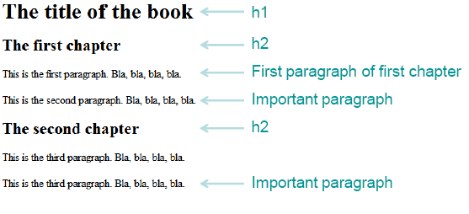
Write the CSS rule as following:
- The main title (h1) is color white on black
- The chapter titles (h2) are blue on yellow
- The default color of paragraphs is green
- The first paragraph of the first chapter is black
- An important paragraph is yellow on red

<html>
<head>
<style>
h1{
color: white;
background-color: black;
}

h2{
color: blue;
background-color: yellow;
}

p{
color: green;
}

.important{
color: yellow;
background-color: red;
}
</style>
</head>
<body>
<h1>PERCY JACKSON and the lightning theif</h1>
<h2>Chapter 1</h2>
<p style="color: black;">Percy Jackson, a demigod.</p>
<p class="important">He is Poseidon's son.</p>
<h2>Chapter 2</h2>
<p>Zeus sword is missing.</p>
<p class="important">Zeus blames Percy Jackson.</p>
</body>
</html>

- Write CSS code to implement the following :
      - Colorize text of a paragraph where RGB value is (51, 204, 0).
      - Put a background image called BKG.GIF behind a single word “TEXT” written with a font size of 39 pixels.
      - Place an image in the background of a page such that the image tiles only in the horizontal direction and the starting position is the horizontal and vertical center of the page.
<html>
<head>
<style>
body{
background-image: url("liyue.jpg");
background-repeat: repeat-x;
top: 50%;
left: 50%;
}

p{
color: rgb(51, 204, 0);
}
</style>
</head>
<body>
<p>A popular game that is played widely by many people. A game with intensive
graphics and stories caught the attention of many.</p>
<p style="background-image: url(bkg.gif); font-size: 39px;">TEXT</p>
</body>
</html>

- Write CSS code to implement the following :
A border around an image element such that the top and bottom borders are 3 pixels wide and of type “dashed” while the left and right borders are 5 pixels wide and of type “solid”. All borders are green in color.

<html>
<head>
<style>
img{
border-top: dotted 3px green;
border-bottom: dotted 3px green;
border-right: solid 5px green;
border-left: solid 5px green;
}

</style>
</head>
<body>
<img src = "liyue.jpg">
</body>
</html>

- Write the CSS code for an image 100 by 100 pixels in dimension and place it at the center of a page. Arrange to change the shape of the cursor to a “crosshair” when positioned over the image.
<html>
<head>
<style>
img{
width: 100px;
height: 100px;
display: block;
margin-left: auto;
margin-right: auto;
cursor: crosshair;
}

</style>
</head>
<body>
<img src = "liyue.jpg">
</body>
</html>

- Use CSS to write the text string “Cascading Style Sheet” dark red in color and in small caps as in a size that approximately covers 50% of the page width. The text should be a hyperlink pointing to a file STYLE.HTM, but without any underline. The stylesheet should remain in an external file.
<html>
<head>
<link rel="stylesheet" href="style.css">
</head>
<body>
<a href = "style.htm"><p>Cascading Style Sheet</p></a>
</body>
</html>

/*Style.css:*/
a{
color: rgb(90, 9, 6);
text-decoration: none;
text-transform: lowercase;
font-size: 100px;
}

p{
font-size: 200%;
}

- Write the CSS rule to display the webpage as shown below
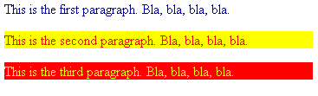

<html>
<body>
<p style="color: blue;">This is the first para blah blah blah</p>
<p style="color: red; background-color: yellow;">This is the first para blah blah blah</p>
<p style="color: yellow; background-color: red;">This is the first para blah blah blah</p>
</body>
</html>

- Replicate the following Web page using CSS
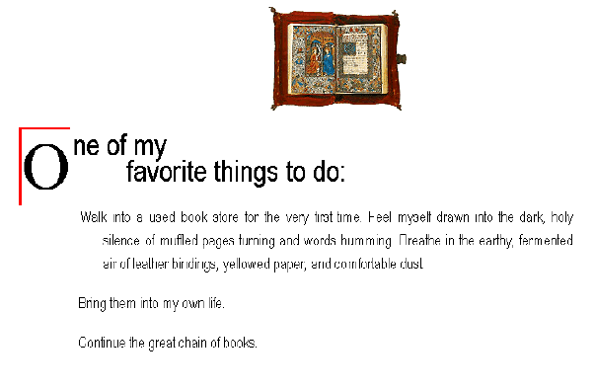

<html>
<head>
<style>
img{
display: block;
margin-left: auto;
margin-right: auto;
width: 500px;
height: 300px;
}

.text{
display: flex;
}
p{
font-size: 20px;
}
.para{
text-align: center;
}
.oletter{
margin-left: 40%;
font-size: 50px;
border-top: solid 1px red;
border-left: solid 3px red;
width: 50px;
height: 50px;
}
</style>
</head>
<body>
<img src="liyue.jpg"><br><br>
<div class = "text">
<div class="oletter">O</div>
<p>ne of my<br>&nbsp&nbsp&nbsp&nbspfavourite things to do:<br><br>Walk into a used book store<br></p>
</div>
</body>
</html>

- Write a CSS rule to display the nested list items. The main category list items should be in the ordered list with property value of upper alpha and all sub category list items should be in the unordered list with property value of square.

<html>
<head>
<style>
ol{
list-style: upper-alpha;
}

ul{
list-style: square;
}
</style>
</head>
<body>
<ol>
<li>Percy Jackson:
<ul>
<li>Lightning theif</li>
<li>Sea of Monsters</li>
<li>Battle of Labyrinth</li>
</ul>
</li>
</ol>
</body>
</html>

- Write the CSS following rules for the link in the web page
  - normal and visited state a background-color of #95b7cd and make their text color the same as the regular text on the page
  - links in their hover state a background-color of #aaddee
  - links in their active state a background-color of #3cc7f0
<html>
<head>
<style>
a{
background-color: #95b7cd ;

}

a:active{
background-color: #aaddee
}

a:hover{
background-color: #3cc7f0;
}
</style>
</head>
<body>
<a href="kaeya.jpg">Kaeya</a><br>
<a href="beidou.jpg">Beidou</a>
</body>
</html>

- Create a text shadow on the phrase "New features in CSS3" with a horizontal offset of 2px, a vertical offset of 5px, a blur radius of 6px and a text-shadow color deepskyblue.
<html>
<head>
<style>

p{
text-shadow: 2px 5px 6px deepskyblue;
}

</style>
</head>
<body>
<p>New features in CSS3</p>
</body>
</html>

- Create a div element with a width and height of 500px. Create a diagonal linear gradient using the colors of the rainbow—Red, Orange, Yellow, Green, Blue, Indigo, Violet.
<html>
<head>
<style>
.box{
width: 500px;
height: 500px;
background-image: linear-gradient(to bottom right, red, orange, green, blue, indigo, violet);
}
</style>
</head>
<body>
<div class="box"></div>
</body>
</html>

- Create a div element with a width and height of 500px. Create a radial gradient with three colors. Start the gradient in the bottom-left corner with the colors changing as they move along the gradient line to the right.

<html>
<head>
<style>
.box{
width: 500px;
height: 500px;
background-image: repeating-radial-gradient(closest-corner at 80% 55%, pink, violet, indigo);
}
</style>
</head>
<body>
<div class="box"></div>
</body>
</html>

- Write the CSS code for below webpage:
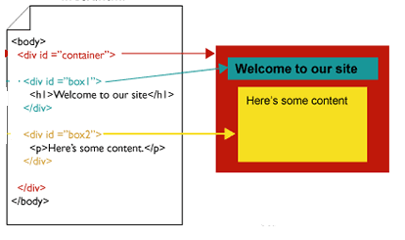

<html>
<head>
<style>
body{
background-color: brown;
}

h1{
background-color: rgb(16, 121, 134);
}

p{
background-color: yellow;
}
</style>
</head>
<body>
<div id="container">
<div id="box1">
<h1>Welcome to our site</h1>
</div>
<div id="box2">
<p>Here's some content</p>
</div>
</div>
</body>
</html>

